Togetherness-Cell Devs Model

Overview:

The cellular automaton called “Togetherness” is based on a random initial system where the cells try to move to empty locations or to swap positions among themselves. By moving to an empty location or swapping positions, the cell will maximize the number of neighbours which are in the same state as that cell (states in this model are colours). The ultimate goal is for all cells of the same state to be together in a single cluster. Rarely can a single cluster of the each state can be achieve. Generally, clusters of same states are formed.

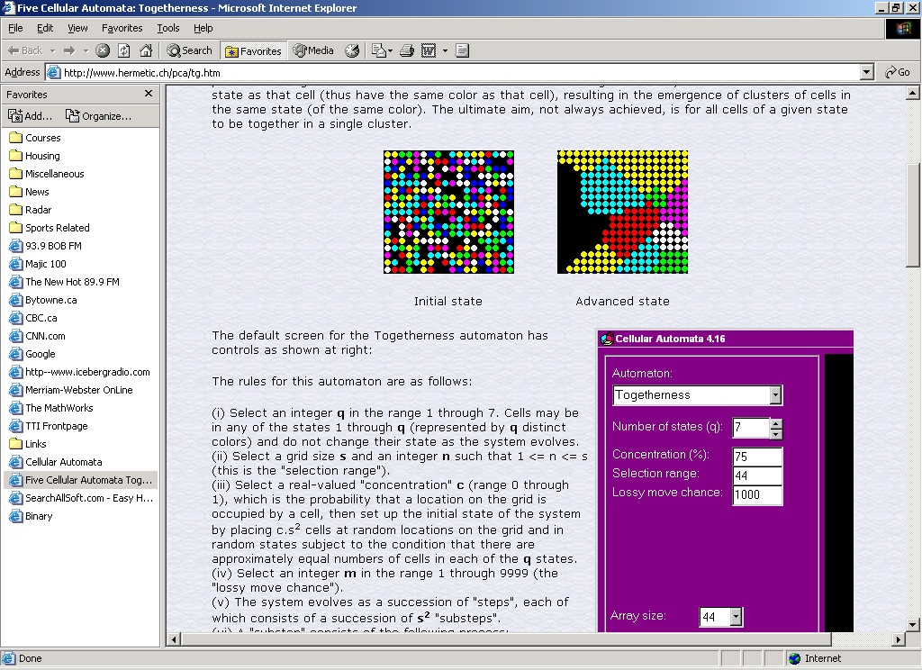

Initial State Final State

Modifications Reason:

The assignment was modified due to the difficulty level in the implementation of the design. The original togetherness design required that there be two separate neighborhoods to keep track of at any given time. The stateCount function would count the “net gain” of swapping a cell of neighbourhood1 with a cell of neighbourhood2. Because it is not possible to keep track of more than one neighborhood using CD++, the only logically method is to declare a large neighborhood. However, a large neighborhood is even more difficult to manage because it would require an increase in the number of rules.

Simplified Togetherness model:

At the advice of the TA, a simplified version of togetherness is implemented. There are 2 planes: Plane1 and Plane2. Plane1 represent the cell states. Plane2 represent the random number to determine the swap. For the sake of simplicity, Plane2 has the same values as Plane 1.

Each cell can be in state 0,1 or 2. If a cell is in state 0, its new state change is the value of its left neighbor.

If a cell is in state 1, its new state change is dependent on its right neighbor value of Plane 2. If the right neighbor on Plane 2 is greater than or equal to its state, then the cell state is set to 1. If the right neighbor on Plane 2 is less than its state, then the cell is set to 2.

If a cell is in state 2, its new state change is dependent on its right neighbor value of Plane 2. If the right neighbor on Plane 2 is greater than or equal to its state, then the cell state is set to 2. If the right neighbor on Plane 2 is less than its state, then the cell is set to 1.

Formal Specifications:

Plane 1:

M=<I,X,Y,Xlist,Ylist,η, N,{m,n}, C, B, Z, select>
Xlist=Φ
Ylist=Φ
η=9
I=<P^{X},P^{y}>,with P^{X}={Φ},P^{y}={Φ};
N={(-1,1,0),(0,1,0),(1,1,0),(-1,0,0),(0,0,0),(1,0,0),(-1,-1,0),(0,-1,0),(1,-1,0)}
X=Y={0,1,2};
m=10; n=10;
B={Φ};
C={Cij/iε[1,10], jε[1,10]}
Z:
P_{ij}^{Y1}→P_{i-1,j}^{X1}
P_{ij}^{Y2}→P_{i,+1j}^{X2}
P_{ij}^{Y3}→P_{i,j}^{X3}
P_{ij}^{Y4}→P_{i,j+1}^{X4}
P_{ij}^{Y5}→P_{i,j-1}^{X5}
P_{ij}^{Y6}→P_{i,-1j}^{X6}
P_{ij}^{Y7}→P_{i,+1j}^{X7}
P_{ij}^{Y8}→P_{i,j-1}^{X8}
P_{ij}^{Y8}→P_{i,j+1}^{X9}

Select={(-1,1,0),(0,1,0),(1,1,0),(-1,0,0),(0,0,0),(1,0,0),(-1,-1,0),(0,-1,0),(1,-1,0)}

Plane 2:

M=<I,X,Y,Xlist,Ylist,η, N,{m,n}, C, B, Z, select>
Xlist=Φ
Ylist=Φ
η=9
I=<P^{X},P^{y}>,with P^{X}={Φ},P^{y}={Φ};
N={(-1,1,1),(0,1,1),(1,1,1),(-1,0,1),(0,0,1),(1,0,1),(-1,-1,1),(0,-1,1),(1,-1,1)}
X=Y={0,1,2};
m=10; n=10;
B={Φ};
C={Cij/iε[1,10], jε[1,10]}
Z:
P_{ij}^{Y1}→P_{i-1,j}^{X1}
P_{ij}^{Y2}→P_{i,+1j}^{X2}
P_{ij}^{Y3}→P_{i,j}^{X3}
P_{ij}^{Y4}→P_{i,j+1}^{X4}
P_{ij}^{Y5}→P_{i,j-1}^{X5}
P_{ij}^{Y6}→P_{i,-1j}^{X6}
P_{ij}^{Y7}→P_{i,+1j}^{X7}
P_{ij}^{Y8}→P_{i,j-1}^{X8}
P_{ij}^{Y8}→P_{i,j+1}^{X9}

Select={(-1,1,0),(0,1,0),(1,1,0),(-1,0,0),(0,0,0),(1,0,0),(-1,-1,0),(0,-1,0),(1,-1,0)}

For all tests, only, one plane is shown as Plane1 and Plane2 contain the same value.

Test 1:

Input:

 | 0 | 1 | 2 | 3 | 4 | 5 | 6 | 7 | 8 | 9
0 | 1 |  | 1 |  | 1 |  | 1 |  | 1
1 | 1 |  | 1 |  | 1 |  | 1 |  | 1
2 | 1 |  | 1 |  | 1 |  | 1 |  | 1
3 | 1 |  | 1 |  | 1 |  | 1 |  | 1
4 | 1 |  | 1 |  | 1 |  | 1 |  | 1
5 | 2 |  | 2 |  | 2 |  | 2 |  | 2
6 | 2 |  | 2 |  | 2 |  | 2 |  | 2
7 | 2 |  | 2 |  | 2 |  | 2 |  | 2
8 | 2 |  | 2 |  | 2 |  | 2 |  | 2
9 | 2 |  | 2 |  | 2 |  | 2 |  | 2

Output:

 | 0 | 1 | 2 | 3 | 4 | 5 | 6 | 7 | 8 | 9
0 | 1 | 1 | 1 | 1 | 1 | 1 | 1 | 1 | 1 | 1
1 | 1 | 1 | 1 | 1 | 1 | 1 | 1 | 1 | 1 | 1
2 | 1 | 1 | 1 | 1 | 1 | 1 | 1 | 1 | 1 | 1
3 | 1 | 1 | 1 | 1 | 1 | 1 | 1 | 1 | 1 | 1
4 | 1 | 1 | 1 | 1 | 1 | 1 | 1 | 1 | 1 | 1
5 | 2 | 2 | 2 | 2 | 2 | 2 | 2 | 2 | 2 | 2
6 | 2 | 2 | 2 | 2 | 2 | 2 | 2 | 2 | 2 | 2
7 | 2 | 2 | 2 | 2 | 2 | 2 | 2 | 2 | 2 | 2
8 | 2 | 2 | 2 | 2 | 2 | 2 | 2 | 2 | 2 | 2
9 | 2 | 2 | 2 | 2 | 2 | 2 | 2 | 2 | 2 | 2

Test 2:

Input:

 | 0 | 1 | 2 | 3 | 4 | 5 | 6 | 7 | 8 | 9
0 | 1 |  | 2 | 1 | 2 |  | 1 |  | 1 | 1
1 | 1 |  | 2 | 1 | 1 |  | 2 |  | 1 | 1
2 | 1 |  | 1 | 1 | 1 |  | 2 |  | 1 | 1
3 | 1 |  | 1 | 1 | 2 |  | 2 |  | 1 | 1
4 | 1 |  | 2 | 1 | 2 |  | 1 |  | 1 | 1
5 | 2 |  | 2 | 1 | 2 |  | 1 |  | 2 | 2
6 | 2 |  | 2 | 1 | 2 |  | 1 |  | 1 | 2
7 | 2 |  | 2 | 1 | 2 |  | 1 |  | 2 | 2
8 | 1 |  | 1 | 1 | 1 |  | 1 |  | 2 | 2
9 | 2 |  | 2 | 1 | 1 |  | 1 |  | 2 | 2
Output:

 | 0 | 1 | 2 | 3 | 4 | 5 | 6 | 7 | 8 | 9
0 | 1 | 2 | 2 | 2 | 2 | 2 | 1 | 1 | 1 | 1
1 | 1 | 2 | 2 | 1 | 1 | 1 | 2 | 2 | 1 | 1
2 | 1 | 1 | 1 | 1 | 1 | 1 | 2 | 2 | 1 | 1
3 | 1 | 1 | 1 | 2 | 2 | 2 | 2 | 2 | 1 | 1
4 | 1 | 2 | 2 | 2 | 2 | 2 | 1 | 1 | 1 | 1
5 | 2 | 2 | 2 | 2 | 2 | 2 | 1 | 1 | 2 | 2
6 | 2 | 2 | 2 | 2 | 2 | 2 | 1 | 1 | 1 | 2
7 | 2 | 2 | 2 | 2 | 2 | 2 | 1 | 1 | 2 | 2
8 | 2 | 1 | 1 | 1 | 1 | 1 | 1 | 1 | 2 | 2
9 | 2 | 2 | 2 | 1 | 1 | 1 | 1 | 1 | 2 | 2

